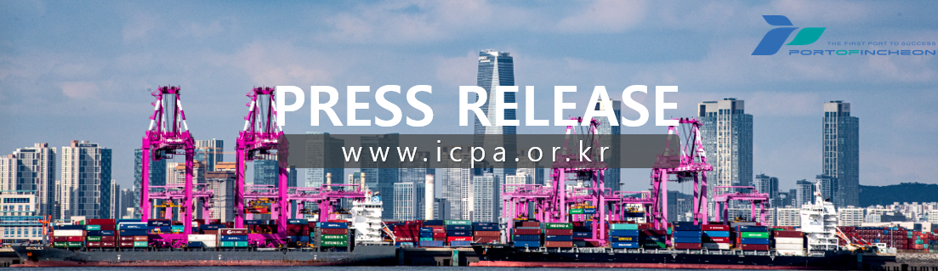
Incheon Port Authority Successfully Completes Port Sales in Taiwan and Vietnam

Spurring Growth in Trade Volume Between Korea, Taiwan, and Vietnam through Active New Routes and Shipper Recruitment

Incheon Port Authority (IPA, www.icpa.or.kr) President Lee Kyung-kyu announced on the 29th that the port sales marketing campaign conducted from the 23rd to the 27th in Taipei, Taiwan, and Ho Chi Minh City, Vietnam, was successfully completed. This port sales initiative was pushed forward as part of a strategic marketing effort to respond to uncertainties in the global shipping market, open new routes at Incheon Port, and expand cargo volume.
The Incheon Port Authority held meetings with top executives of major Taiwanese shipping lines, including TS Lines, Evergreen, and Wan Hai Lines. IPA comprehensively presented Incheon Port's strong logistics infrastructure competitiveness, excellent port accessibility, and the high demand from the Seoul metropolitan hinterland, emphasizing the necessity of opening new services and expanding port calls. Furthermore, IPA provided detailed explanations on the plans to introduce a fully automated port and expand large-vessel accommodation capacity following the opening of Phases 1-2 of Incheon New Port in the second half of 2028, along with incentive programs and operational support policies.
Particularly, amid expanding vessel supply driven by consecutive deliveries of newly built container ships, Taiwanese shipping companies expressed consensus on Incheon Port's locational value and growth potential. They stated that they would consider calling at Incheon Port as a highly viable option for their future fleet operations.
During the itinerary in Vietnam, IPA signed a Memorandum of Understanding (MOU) with the SP-ITC terminal to build a foundation for cooperation across various fields, including increasing container cargo volume, port infrastructure and technology, and route operations. Following this, IPA hosted the 'Incheon Port Ho Chi Minh Forum' to introduce Incheon Port's logistics competitiveness to local logistics companies and expand the foundation for bilateral cooperation between Korea and Vietnam.
Additionally, through meetings with Korean furniture manufacturers operating in Vietnam, IPA discussed measures to increase the use of Incheon Port for importing and exporting furniture products. The authority conveyed its commitment to service improvement and stable logistics support, while also sharing details regarding incentive programs tailored for shippers.
At the same time, a meeting with local national shipping lines was held to review the current status of Southeast Asian route operations and discuss cooperative measures for expanding Incheon Port calls and establishing new services, thereby establishing an opportunity to further strengthen the cooperative network among shipping lines, shippers, and the port.
Based on the network established with shipping lines, shippers, and terminals through this port sales tour, Incheon Port Authority plans to actively promote the opening of new routes and the stabilization of existing routes, while continuously strengthening the foundation for long-term growth in Incheon Port's cargo trade volume.
IPA President Lee Kyung-kyu stated, 'Taiwan and Vietnam are core trading partners of Incheon Port. Through this port sales campaign, we verified the strong potential for opening new routes and attracting shippers.' He added, 'We will continue to enhance the global competitiveness of Incheon Port through aggressive overseas marketing targeting emerging Asian markets.'

