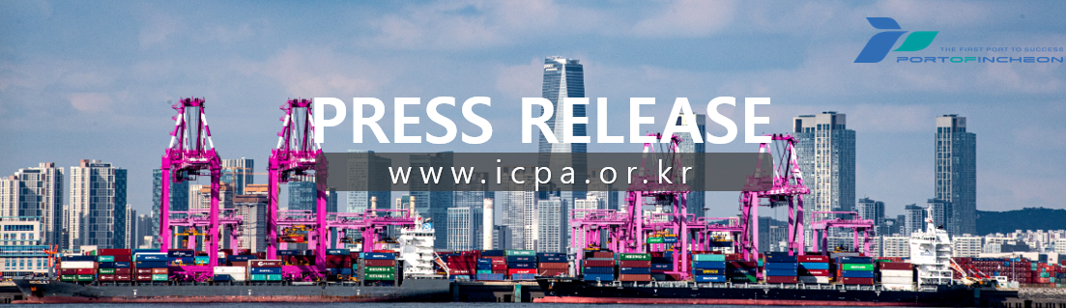
The Beginning of Smart Logistics Innovation: Opening of Incheon Port Smart Joint Logistics Center

Opening Ceremony Held on February 10th, Expected to Reduce Logistics Operation Time and Operating Costs

Incheon Port Authority (www.icpa.or.kr, CEO Lee Kyung-gyu) announced that on February 10th (Tuesday), it held the opening ceremony of the Incheon Port Smart Joint Logistics Center (160 Gukjehangman-daero, Yeonsu-gu, Incheon) jointly with the Ministry of Oceans and Fisheries, officially starting its full-scale operations.
The Incheon Port Smart Joint Logistics Center was constructed with 3 floors above ground and a total floor area of 19,085 square meters in the Aam Logistics Cluster 2 (Incheon South Port Logistics Park) in Songdo International City, Incheon, with a total project cost of 38.2 billion won.
The Incheon Port Smart Joint Logistics Center is equipped with automated cargo loading/unloading and storage functions utilizing smart robots and Internet of Things (IoT) sensors.
In addition, real-time inventory management and predictive modeling of customer demand are enabled through big data analysis utilizing artificial intelligence (AI). Compared to conventional logistics centers, operation time and cargo processing error rates are expected to drop by approximately 10–20%, while productivity and space utilization will increase by up to 30%, leading to an operating cost reduction of over 20%.
When the government and public institutions directly build and supply logistics centers, like this Incheon Port Smart Joint Logistics Center, the burden on small and medium-sized logistics companies regarding high initial costs and financing is significantly reduced.
Furthermore, by ensuring that more than 50% of the cargo volume is allocated to handling products from small and medium-sized enterprises (SMEs), it is expected to bring positive effects by relieving the logistics cost burden on small and medium-sized import and export shippers.
Lee Kyung-gyu, CEO of Incheon Port Authority, stated, "At a time when smart technology is transforming the standards of the logistics industry, I hope this joint logistics center will serve as an opportunity to enhance the competitiveness of small and medium-sized enterprises." He added, "We will leap forward based on the integration of smart technology across Incheon Port, including the port hinterland, and the value of win-win cooperation."
[END]

