PRESS RELEASE | www.icpa.or.kr
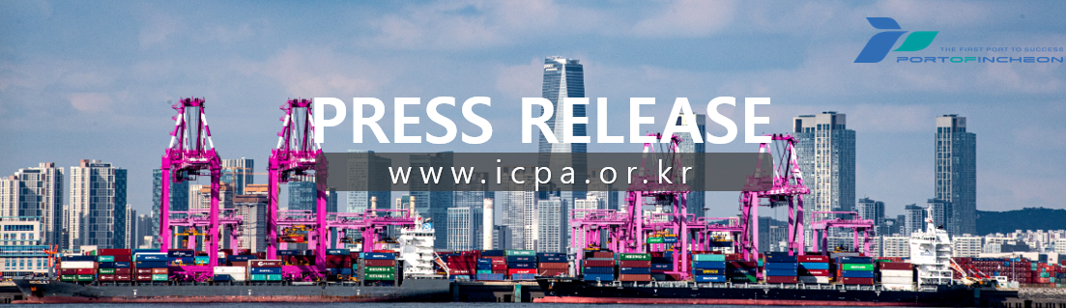
Incheon Port Authority Launches New Direct Route Connecting Incheon and Indonesia (Jakarta/Surabaya)

Expected to Boost Annual Cargo Volume by 120,000 TEU

○ Incheon Port Authority (IPA, www.icpa.or.kr, President Lee Kyung-kyu) announced that the KCI (Korea-China-Indonesia) regular container service officially commenced operations at Incheon Port on the 13th.
○ The KCI service operates on a weekly basis, calling at Incheon – Qingdao – Shanghai – Jakarta – Surabaya – Shekou – Busan – Incheon. A total of four container ships ranging from 2,200 TEU to 2,954 TEU will be deployed sequentially on this route.
○ For the maiden voyage of this new service, Interasia Lines’ ‘INTERASIA ENGAGE’ (2,200 TEU class) docked at the Hanjin Incheon Container Terminal (HJIT) on the 13th. Subsequently, vessels from TS Lines, GSL, and Namsung Shipping will be deployed in sequence to ensure stable route operations.
○ IPA expects this new route to significantly improve import and export logistics accessibility, particularly to the Jakarta and Surabaya regions in Indonesia. In particular, it is projected to generate over 120,000 TEU of new cargo annually, driven by export items such as waste paper and polyvinyl chloride (PVC) bound for Jakarta, and import items like furniture from Shekou (Shenzhen), China.
○ The KCI route was established as part of Incheon Port's 'New Growth Market-Oriented Route Diversification Strategy.' IPA explained that this achievement is a tangible result of its ongoing port sales marketing targeting shipping lines, shippers, and forwarders in Indonesia, alongside promoting its strategic region incentive system.
○ Lee Kyung-kyu, President of IPA, stated: 'The launch of this new regular route to Indonesia serves as a crucial milestone directly connecting Incheon Port with emerging growth markets in Southeast Asia.' He added, 'We will continue to support the logistics competitiveness of import and export enterprises in the Seoul metropolitan area through aggressive marketing and route attraction in Indonesia and other new growth markets.'
○ Meanwhile, Incheon Port opened nine new container routes last year, achieving a milestone of operating a total of 72 regular container routes.

