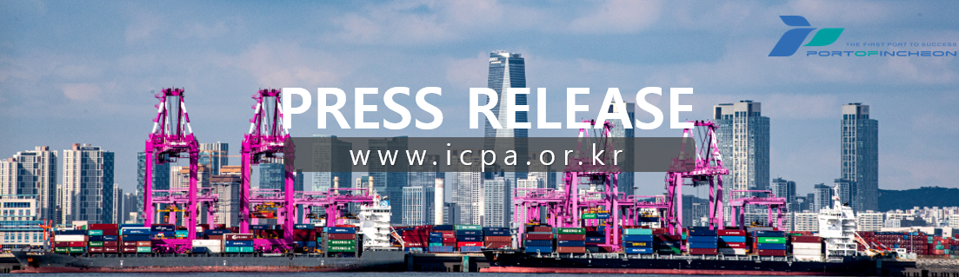
Port of Incheon Welcomes Its Largest Cruise Ship Since Opening

MSC Cruises' 170,000-Ton 'MSC Bellissima' Enters Port of Incheon with Over 3,300 Passengers

Incheon Port Authority (www.icpa.or.kr, CEO Lee Kyung-gyu) announced that on February 6th at 5:30 AM, the 'MSC Bellissima' of MSC Cruises, the largest cruise ship in the history of the Incheon Port Cruise Terminal, successfully entered the Port of Incheon.
The MSC Bellissima arrived at the Port of Incheon carrying approximately 3,300 passengers and 1,600 crew members. The vessel departed from Shanghai, China, on February 4th, arrived at the Port of Incheon on February 6th, and set sail on the same day at 9:30 PM, returning to Shanghai on February 8th.
In preparation for the arrival of the largest cruise ship ever to call at the port, Incheon Port Authority worked in close coordination and prior consultation with relevant organizations including Customs, Immigration, and Quarantine (CIQ), ensuring smooth and seamless processing without any disruption.
To commemorate the maiden call of the MSC Bellissima at the Port of Incheon, Incheon Port Authority presented a commemorative plaque to the captain and cruise line officials. The authority requested continued calls to the Port of Incheon in the future and promised stable operational support.
Lee Kyung-gyu, CEO of Incheon Port Authority, stated, "The arrival of the MSC Bellissima proves once again that the Port of Incheon possesses the capacity to accommodate ultra-large cruise ships." He added, "We will continue to create a seamless processing environment through close cooperation with CIQ* agencies and develop the Port of Incheon into a reliable global cruise hub."
* CIQ Agencies: Refers to Customs, Immigration, and Quarantine agencies.
[END]

