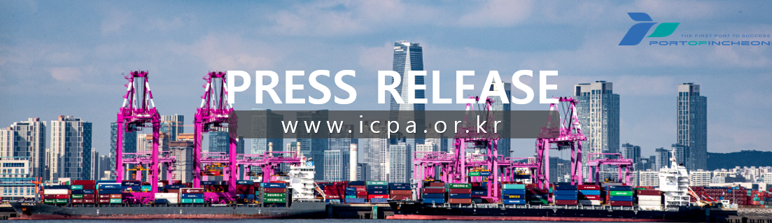
Incheon Port Authority Donates Full Amount of 5 Million Won Prize Money as "READY Korea" Outstanding Institution

Joining the '119 Won Miracle' to Help Fire Victims. Returning Disaster Response Achievements as Social Value, Leading the Spread of a 'Safety Culture'

○ Incheon Port Authority (www.icpa.or.kr, CEO Lee Kyung-gyu) announced on the 15th that it donated the entire 5 million won prize money received for being selected as an outstanding institution in the 'READY Korea' evaluation organized by the Ministry of the Interior and Safety to the '119 Won Miracle', a support project for fire victims.

○ The '119 Won Miracle' started with voluntary donations from Incheon firefighters and is currently operated by the Community Chest of Korea.

○ This donation was organized to empathize with the dedication of firefighters who face danger first at the scene and to convey a message of solidarity. Incheon Port Authority sought to spread the value of safety throughout society by returning the prize money—received as a result of continuous efforts to strengthen its capabilities as a disaster response organization—as a contribution to those who protect disaster scenes.

○ In particular, the '119 Won Miracle' is a project that was voluntarily started among firefighters to provide material support and hope to individuals with unfortunate stories encountered while navigating disaster scenes. Incheon Port Authority selected it as the donation recipient out of deep empathy for its purpose. The donated funds will be used for projects related to stabilizing the livelihoods of citizens facing difficulties due to fire damage.

○ Lee Kyung-gyu, CEO of Incheon Port Authority, said, "Being selected as an outstanding institution for READY Korea is the result of all executives and employees prioritizing safety as a top value and working responsibly in their respective positions." He added, "I hope this meaningful prize money leads to safety at another scene through the '119 Won Miracle,' and we will continue to fulfill our responsibility as a public institution that prioritizes the values of life and safety."

○ Meanwhile, Incheon Port Authority continuously carries out various social contribution activities, such as donations and volunteer work, contributing to mutual prosperity with the local community and sustainable development.
[END]

